Post Out Going Payment with Bill of Exchange (Imports)

S.NO. : 01- FI-AP- 07

TRANSACTION CODE : F – 53

ACCESS PATH : SAP Easy Access Accounting Financial
Accounting Accounts Payable Document
Entry Out going payment Post

We get “ Post Out Going Payment” Header data” screen ;

Required Fields:

Document date : To be entered
Account : To be entered (Vendor A/c Number)
Account Type : Default
Standard Ois : Default Ticked
Account : To be entered (Bank A/c Number)
Posting date : Default
Amount : Total amount to entered in Euro
Bank Charges : To be entered in Inr

Rest all other fields viz, Doc Type, Period, Companycode,Currency are default after they are entered for the first time.Exchange rate also to be entered (eg: 44 Current Market Rate on the day of making Payment)

We get the Screen “Post Out Going Payment - Header Data“ incorporating the
above mentioned required fields as under;

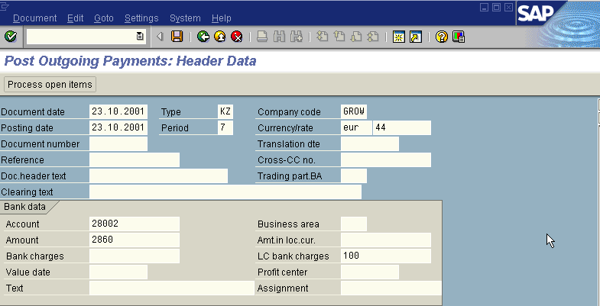
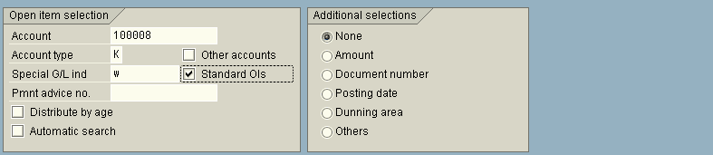

The point to be noted in the above “Post Out Going Payment - Header Data” screen is we have to fill the Spl. G/L Indicator field with “W” (bill of exchange- Bankable) because we are clearing the Spl. G/L item bill of exchange against the invoice.

In the above “Post Out Going Payment - Header Data” screen, with help of the mouse place the cursor on the SPL. G/L Indicator field

Press F4

We get the “possible entries- Spl. G/L Indicator” screen as under
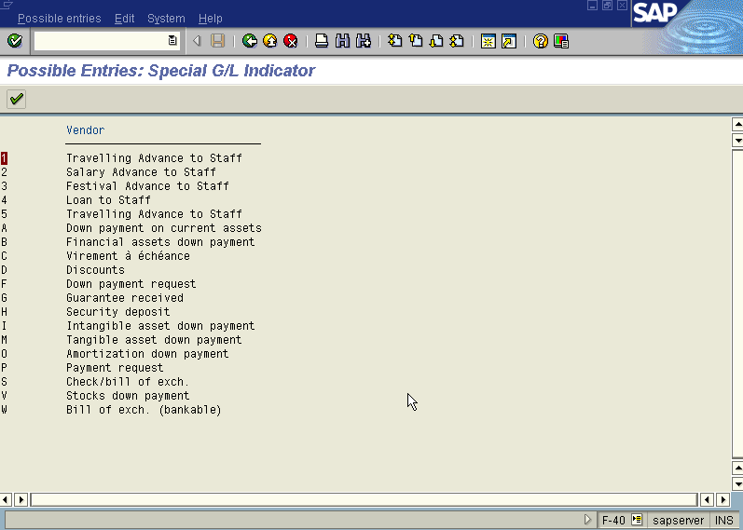

Double Click the last item “W” (Bill of Exchange- Bankable) with the help of the mouse,

Press button

Press button

so that the item “W” appears on the above “Post Out Going Payment - Header Data ” screen under the field “ Spl. G/L ind.”.

Press button

The system gives a message as under

Press Enter Icon

A screen relating to the “Tax Data” will appear as under

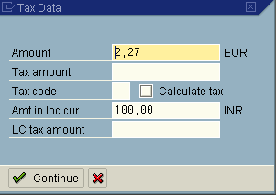

Press button

The system will display the below message

Press button

Now we get “ Post Out Going Payment – Process Open Items” screen as below
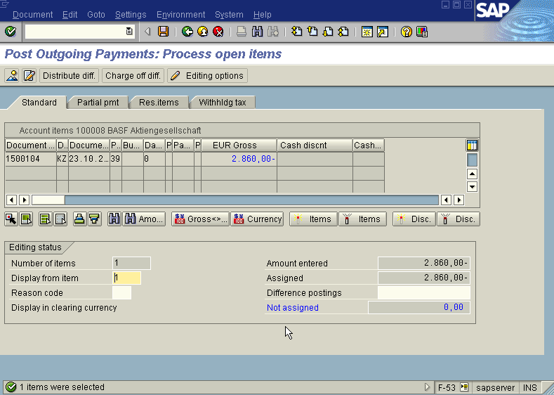

In the above “ Post Out Going Payment – Process Open Items” screen

Press icon (Select all) so that all items will be highlighted in blue.

Press icon (Deactivate items) so that all items highlighted in blue turns to normal in black

Now use the Scroll bar on the above “ Post Out Going Payment – Process Open Items” screen till we find our Invoice on the above Screen. Then once we have found the Invoice we wanted to post, Just double click with the mouse on the Amount field (eg. 2860 Euro in this case) so the amount highlighted will turn to blue colour and the Not assigned field will turn to Zero . Here we should keep in mind that this Not assigned field has to be brought to zero to make the posting.

Press Save button

The system will display a message as under

Take a note of the document number ; 1500105

This is the stage where “Post Out Going payment” stage is complete

The document can be seen from Document Display from the top left hand side of the main screen “post out going payment - Header Data“ OR from Transaction code FB- 03 .The Document overview screen will be displayed as under showing the entries.

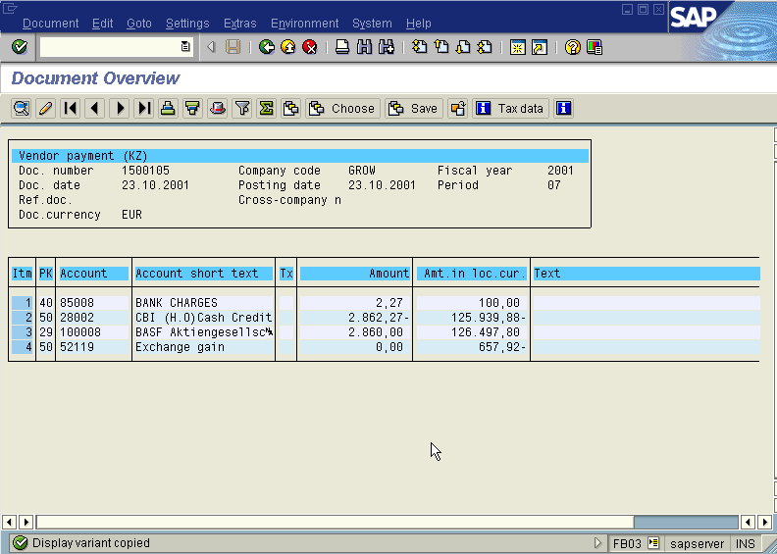

In the above screen the field amount in local currency can be got by clicking button and we are displayed with “Display Variant choose” screen as under

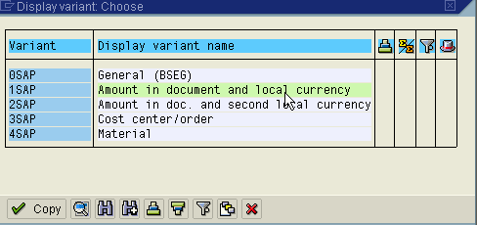

In the above screen choose variant Amount in document and local currency so that in the above “Document Overview” screen showing the entries passed the amount field will appear in Euro & Inr currency.

To know the exchange rate quoted press (Document Header) Icon from “ Document Overview” screen. We get “ Document Header – Company Code GROW” screen as under from which we can see the exchange rate quoted as under.

